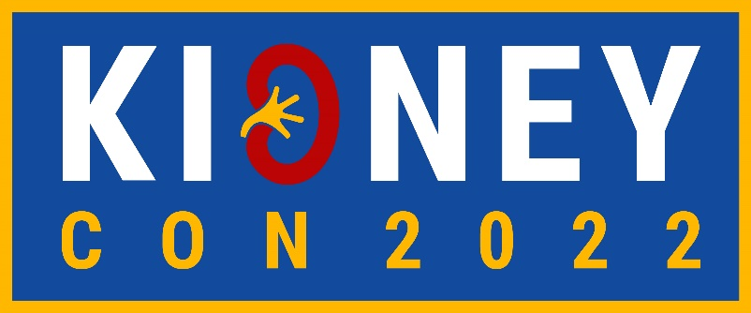
FRIDAY, APRIL 29, 2022
WORKSHOPS (9:00 AM – 4:45 PM CST)
Workshop Title | Workshop Description | Instructors
9:00 AM – 11:00 AM CST
Kidney Pathology | Taught from Arkana, this course discusses cases to teach pathology and understanding glomerular disease. | Shree Sharma, MD, FASN, Alejandro Best, MD (both from Arkana Laboratories)
11:30 AM – 1:30 PM CST
Peritoneal Dialysis | Explores the types of peritoneal dialysis, patient eligibility, and benefits to home treatment. | Joanne Bargman, MD, FRCPC (U of Toronto), Manisha Singh, MD (UAMS)
1:45 PM – 3:45 PM CST
Urine Microscopy | Teaches performance and interpretation of microscopic examination of the urinary sediment. | Juan Carlos Velez, MD (Ochsner Clinic), Jay Seltzer, MD (Missouri Baptist Medical Center)
4:00 PM – 4:45 PM CST
Keynote Address | “Nephrology: A Journey of Sorts.” | Manisha Singh, MD (UAMS)
SATURDAY, APRIL 30, 2022
SCIENTIFIC AND CLINICAL SESSIONS (8:30 AM – 5:00 PM CST)
8:30-9:00 AM | Welcome | John A John Arthur, MD, PhD, FASN (UAMS)

Emerging Approaches to Reduce Glomerular Damage - Moderated by Itunu Owoyemi, MD (U of Kansas)
9:00-9:30 AM | Overview: Glomerular Physiology and Hemodynamics | Juan Edgar Lerma, MD, FASN (Associates in Nephrology)
9:30-10:00 AM | Aldosterone in Diabetes and Other Glomerular Diseases | Christos Argyropoulos, MD, MS, PhD, FASN (U of New Mexico)
10:00-10:30 AM | New Approaches to Treating Glomerular Diseases | Dia Waguespack, MD (U of Texas, McGovern)
10:30-11:00 AM | Endothelin Antagonists | Donald Kohan, MD, PhD (U of Utah)
11:00-11:30 AM | Break
Achieving Health Equity in Kidney Care - Moderated by Dinushika Mohottige, MD, MPH (Duke)

11:30 AM-12:00 PM | Latinx Kidney Health Policy and Advocacy | Lilia Cervantes, MD (U of Colorado)
12:00-12:30 PM | Disparities Impacting African Americans | Opeyemi Olabisi, MD, PhD (Duke)
12:30-1:00 PM | Structural Barriers to Kidney Care | Tessa Novick, MD, MSW (U of Texas at Austin)
1:00-1:30 PM | Native American Kidney Health Equity | Larissa Myaskovsky, PhD (U of New Mexico)
1:30-2:00 PM | Break
Interactive, Multi-Site Point of Care Ultrasound Workshop
Time | Workshop Description | Instructors
2:00 – 5:00 PM | Institutions will receive live training on the techniques of intravascular volume assessment using POCUS. | Nithin Karakala, MD (UAMS), Nathaniel Reisinger, MD (U of Pennsylvania), Abhilash Koratala, MD, FASN (Medical College of Wisconsin)

